Common Kubernetes Terms — Beginner's Guide
Kubernetes (K8s) is an open-source container orchestration platform that automates deploying, managing, scaling, and recovering containerized applications.
Below are the most common Kubernetes terms, their definitions, and practical examples.
1. Kubernetes Core Components
Term | Definition
Cluster | A collection of machines running Kubernetes applications.
Node | A physical or virtual machine that runs workloads.
Control Plane | Components that manage the cluster and make scheduling decisions.
Worker Node | A node that runs application workloads in Pods.
Pod | The smallest deployable unit in Kubernetes; contains one or more containers.
Container | A packaged application with its dependencies.
Image | A read-only template used to create containers.
Namespace | A logical partition used to organize Kubernetes resources.
kubelet | An agent on each node that ensures assigned Pods and containers are running.
Container Runtime | Software such as containerd that runs containers.
2. Kubernetes Architecture
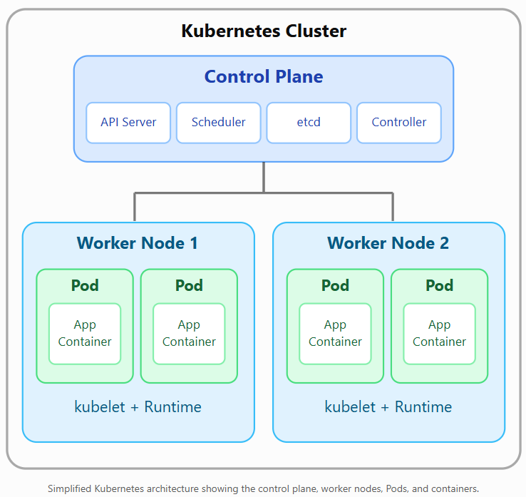
Simplified Kubernetes architecture showing the control plane, worker nodes, Pods, and containers.
Example: A Java application may run in three Pods distributed across two worker nodes. Kubernetes monitors these Pods and can replace them if they fail.
3. Application Deployment and Scaling
Term | Definition
Deployment | Manages application Pods and supports rolling updates and rollback.
Replica | A copy of a Pod used to increase availability or capacity.
ReplicaSet | Maintains the desired number of matching Pods.
StatefulSet | Manages stateful applications requiring stable identities and storage.
DaemonSet | Ensures a Pod runs on every eligible node, or selected nodes.
Job | Runs a task to completion.
CronJob | Runs Jobs on a recurring schedule.
Rolling Update | Gradually replaces older Pods with newer ones.
Horizontal Pod Autoscaler (HPA) | Automatically adjusts the number of Pods based on metrics.
Self-Healing | Kubernetes detects failures and replaces or restarts affected workloads.
Example: Deployment with three replicas
apiVersion: apps/v1
kind: Deployment
metadata:
name: java-app
spec:
replicas: 3
selector:
matchLabels:
app: java-app
template:
metadata:
labels:
app: java-app
spec:
containers:
- name: java-container
image: nginx:latest
ports:
- containerPort: 80
This example creates three replicas of an Nginx container, despite the illustrative Deployment name java-app.
4. Kubernetes Networking Terms
Term | Definition
Service | Provides a stable network endpoint for accessing a group of Pods.
ClusterIP | A Service type accessible inside the cluster.
NodePort | Exposes a Service on a port of each node.
LoadBalancer | Exposes a Service through an external load balancer, when supported.
Ingress | Defines HTTP/HTTPS routing rules for incoming traffic.
Ingress Controller | Implements the routing rules defined by Ingress resources.
Gateway API | A newer, more expressive set of APIs for traffic routing.
CoreDNS | Provides DNS-based service discovery inside Kubernetes.
NetworkPolicy | Controls allowed network traffic between Pods and other endpoints.
CNI | Container Network Interface, used by networking plugins to configure Pod networking.
Example network flow
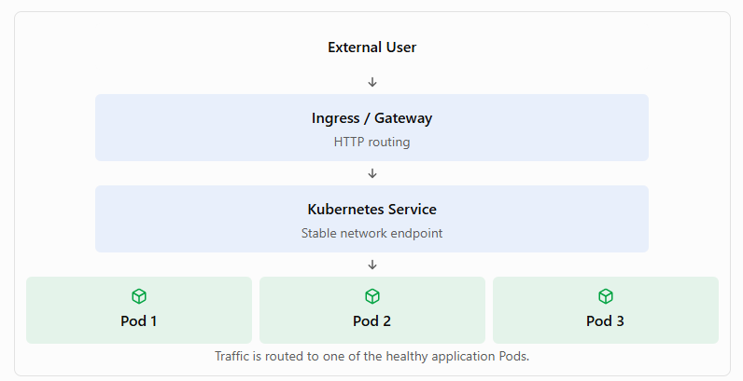
Traffic is routed to one of the healthy application Pods.
5. Kubernetes Storage Terms
Term | Definition
Volume | Storage mounted into containers within a Pod.
PersistentVolume (PV) | A cluster storage resource with a lifecycle independent of a particular Pod.
PersistentVolumeClaim (PVC) | A request for persistent storage by an application.
StorageClass | Defines a class of storage and its provisioning behavior.
CSI | Container Storage Interface, allowing Kubernetes to integrate with storage systems.
emptyDir | Temporary storage shared by containers in a Pod, deleted when the Pod is removed from its node.
Example: A PostgreSQL database uses a PVC so its data can survive Pod replacement.
6. Configuration and Security
Term | Definition
ConfigMap | Stores non-sensitive application configuration.
Secret | Stores sensitive values such as passwords and tokens; additional encryption and access controls are recommended.
ServiceAccount | Provides an identity for workloads interacting with Kubernetes APIs.
RBAC | Role-Based Access Control, governing permissions to Kubernetes resources.
Role | Defines permissions within a namespace.
ClusterRole | Defines permissions that can apply cluster-wide or to namespaced resources.
RoleBinding | Assigns a Role or ClusterRole within a namespace.
Resource Requests | CPU and memory amounts used by Kubernetes for scheduling.
Resource Limits | Configured maximum resource usage constraints for containers.
SecurityContext | Specifies security-related settings for Pods and containers.
7. Health, Monitoring, and Operations
Term | Definition
Liveness Probe | Checks whether a container needs to be restarted.
Readiness Probe | Checks whether a container is ready to receive traffic.
Startup Probe | Allows slow-starting applications time to initialize.
kubectl | Command-line tool used to manage Kubernetes resources.
Helm | Package manager used to install and manage Kubernetes applications.
Helm Chart | A collection of templates and configuration for deploying an application.
Operator | Software that extends Kubernetes controllers to automate application operstate.ations.
CRD | CustomResourceDefinition, used to extend the Kubernetes API with new resource types.
etcd | Distributed key-value store holding Kubernetes cluster
8. Most Common kubectl Commands
Command | Purpose
kubectl get pods | List Pods in the current namespace.
kubectl get nodes | List cluster nodes.
kubectl get deployments | List Deployments.
kubectl get services | List Services.
kubectl get namespaces | List namespaces.
kubectl describe pod my-pod | Show detailed Pod information.
kubectl logs my-pod | Display container logs.
kubectl apply -f app.yaml | Create or update resources from YAML.
kubectl delete -f app.yaml | Delete resources defined in YAML.
kubectl scale deployment my-app --replicas=5 | Scale a Deployment to five Pods.
kubectl rollout status deployment/my-app | Check Deployment rollout progress.
kubectl exec -it my-pod -- /bin/sh | Open a shell in a running container, if available.
9. Kubernetes vs. Docker vs. Databricks
Technology | Primary purpose
Docker | Build and run application containers.
Kubernetes | Orchestrate containers across clusters.
Apache Spark | Distributed data processing engine.
Databricks | Managed data, analytics, and AI platform built around technologies such as Spark and Delta Lake.
Kubernetes and Spark both distribute work across machines, but they solve different problems. Kubernetes schedules and manages containerized workloads, while Spark executes distributed data-processing tasks. Spark can run on Kubernetes, and Databricks abstracts much of the underlying infrastructure management.
10. Top 10 Kubernetes Terms to Learn First
For beginners and technical interviews, prioritize:
- Cluster — Group of Kubernetes machines.
- Node — Machine participating in the cluster.
- Pod — Smallest deployable Kubernetes workload unit.
- Container — Packaged application and dependencies.
- Deployment — Manages stateless application replicas.
- Service — Stable network access to Pods.
- Namespace — Logical resource organization.
- ConfigMap — Non-sensitive configuration.
- Secret — Sensitive configuration data.
- kubectl — Kubernetes command-line interface.
Official reference: Kubernetes Concepts Documentation.

